Appendix A: The Relationship between the various types of PCC History and Physical Architecture

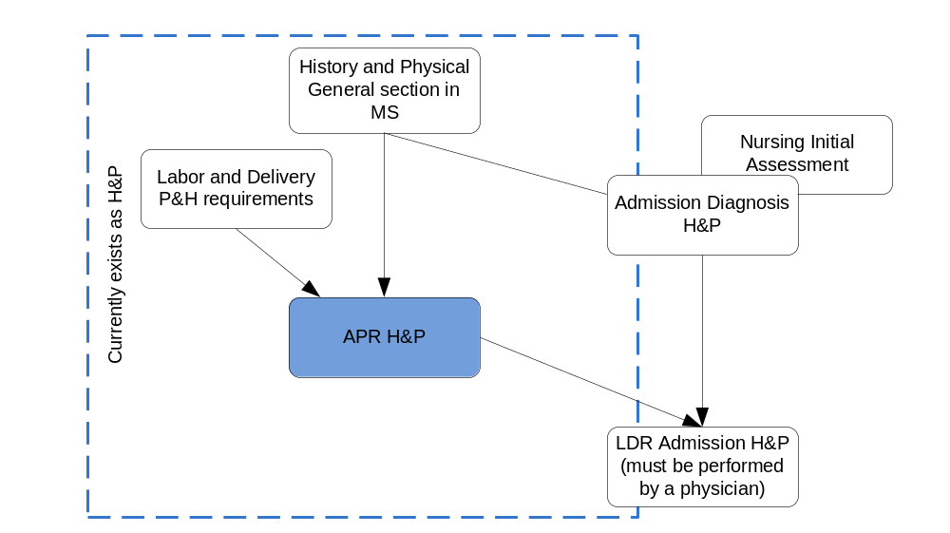

The History and Physical section present in an Admission Diagnosis Assessment contains more information then a general History and Physical Section. The Physical and History section present in a LDR Admission Assessment contains more information then the History and Physical section present in Admission Diagnosis Assessment. This can be seen in the above diagram.

There is also a Nursing Initial Assessment, but a physician has to do a History and Physical Admission Assessement for the Labor and Delivery as per the Joint Commission recommendations. These documents are all part of the History and Physical in general. A consensus must be established as to what documents will be part of the LDR record.

